TABERNACLES SHADOWS
=of the=
"Better Sacrifices"
----------
A Helping Hand
--FOR--
THE ROYAL PRIESTHOOD
----------
To the King of Kings and Lord of Lords
IN THE INTEREST OF
HIS CONSECRATED SAINTS,
WAITING FOR THE ADOPTION,
--AND OF--
"ALL THAT IN EVERY PLACE CALL UPON THE LORD,"
"THE HOUSEHOLD OF FAITH,"
--AND OF--
THE GROANING CREATION, TRAVAILING AND WAITING FOR THE
MANIFESTATION OF THE SONS OF GOD,
THIS WORK IS DEDICATED.
"To make all see what is the fellowship of the mystery which from the beginning
of the world hath been hid in God." "Wherein He hath abounded toward
us in all wisdom and prudence, having made known unto us the
mystery of His will, according to His good pleasure which
He hath purposed in Himself; that in the dispensation
of the fulness of the times He
might gather together in one all
things, under Christ."
Eph. 3:4,5,9;1:8-10
(Originally Published in 1881)

foreword i
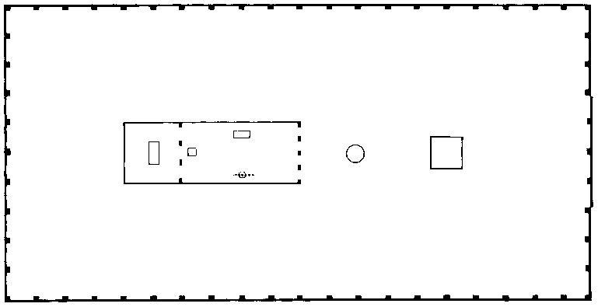

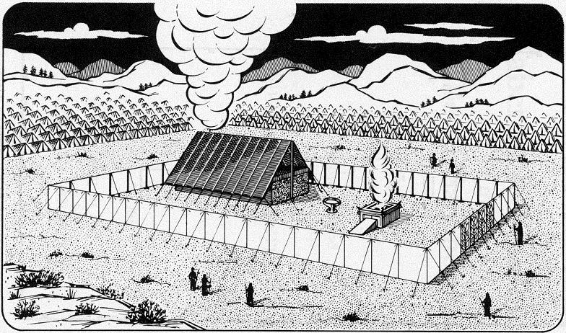
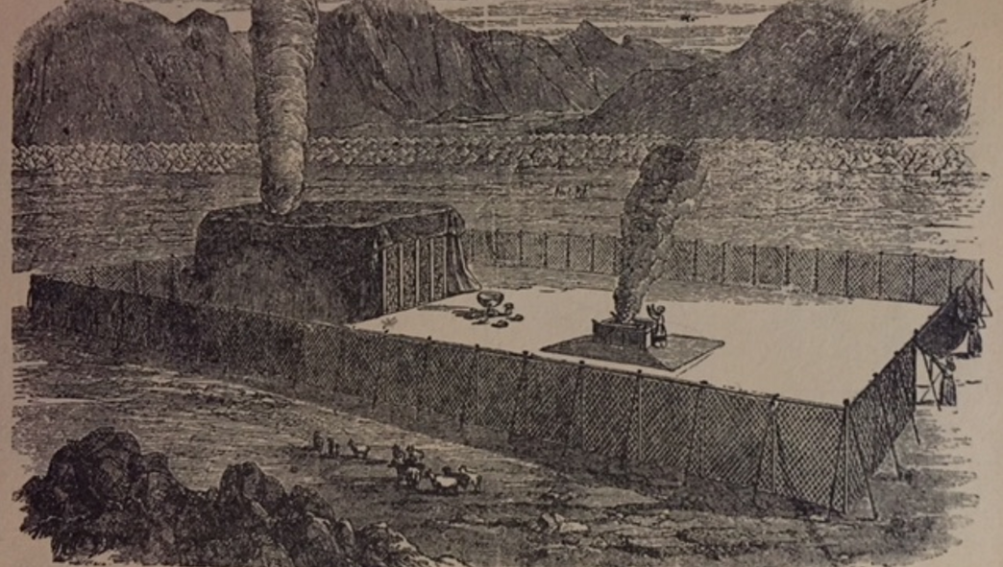

PREFACE (two prefaces, 1882 and 1899) [R3824 how Tabernacle revealed]
The first edition of this little book was published in 1881, and under the Lord's blessing seems to have been very helpful to the class for which it was specially intended, --the "royal priesthood." Many of this class have confessed that as the finger of the Lord it pointed out to them meanings in the Old Testament types never before appreciated; and that it has thus guided them in the way of self-sacrifice, by leading them to see the true significance of the Scriptural declarations--"Present your bodies living sacrifices," "Fill up that which is behind of the afflictions of Christ," "If we suffer with him we shall also reign with him," "Let us go to him outside the camp, bearing the reproach with him"; besides many other Scripture statements which associate the Lord's people with himself both "in the sufferings of this present time and the glory to follow. Rom 8:18 For I reckon that the sufferings of this present time are not worthy to be compared with the glory which shall be revealed in us.."

1Pe 2:9 But ye are a chosen generation, a royal priesthood, an holy nation, a peculiar people; that ye should shew forth the praises of him who hath called you out of darkness into his marvellous light:
Rom 12:1 I beseech you therefore, brethren, by the mercies of God, that ye present your bodies a living sacrifice, holy, acceptable unto God, which is your reasonable service.
Col 1:24 Who now rejoice in my sufferings for you, and fill up that which is behind of the afflictions of Christ in my flesh for his body's sake, which is the church:
2Ti 2:12 If we suffer, we shall also reign with him: if we deny him, he also will deny us:
Heb 13:13 Let us go forth therefore unto him without the camp, bearing his reproach.
Rom 8:18 For I reckon that the sufferings of this present time are not worthy to be compared with the glory which shall be revealed in us.

The author rejoices that this is true, and prays the divine blessing also upon this new edition, which was made necessary by reason of the electro-plates of the former edition being worn, and by the desire to have its general style conform to that of the Scripture Studies series--for it may properly be considered a supplement and sequel to the fifth volume of that work, kept separate for convenience. Aside from these typographic changes, and the addition of one chapter, and a few alterations in the phraseology to make some points possible more perspicuous*, there are no changes. Indeed, no particular changes seemed possible or desirable.
*[per-spik-you-us -- Clear-cut, luminous, obvious, distinct, plain, transparent]
foreward ii
The understanding of the subjects herein set forth would seem to have been heaven directed, "taught of God," at a time when the light was absolutely necessary to the full and clear presentation of the Plan of the Ages. And those who have been blessed by the helps furnished in this little book, and others who shall yet be similarly blessed, we trust, may all esteem that they are also "taught of God"; for be it noted that the author has sought to prove every point and every application by the Word of the Lord, and has taught nothing of himself: as he has received of the Lord through his Word and spirit he has presented the same --with the evidences--to whosoever has an ear to hear.
Joh 6:45 It is written in the prophets, And they shall be all taught of God. Every man therefore that hath heard, and hath learned of the Father, cometh unto me.
1Th 4:9 But as touching brotherly love ye need not that I write unto you: for ye yourselves are taught of God to love one another.
Psa 71:17

The careful student will discern that, the applications of the types herein presented being correct, the entire Plan of the Ages is thereby corroborated -- justification, sanctification, and glorification first for the Church, and subsequently restitution for whoever will, of all the families of the earth. To what a glorious gospel, then, is this the key!
Dear Reader, if the matters herein presented appeal to you as truth at all, they will surely awaken you to energy and zeal to sacrifice earthly interests, to gain the prize of the high calling--that you may become one of the royal priests soon to be associated with the great "High Priest of our profession" in the grand work of blessing the groaning creation. And if you get a blessing from these truths, and partake of their spirit, you will want to pass the cup of refreshment on to others who need just such a stimulus to revive their fainting hearts. And if you desire to colabor in this ministry you will find that all arrangements have been perfected by which you can obtain these booklets at a very nominal price--by the dozen or hundred. Every one who receives food at the Lord's table is honored with the privilege of joining in the service--as "colaborers together with God." With Christian love,
Your brother and servant in Christ,
Charles T. Russell

Joh 2:17 And his disciples remembered that it was written, The zeal of thine house hath eaten me up.
Php 3:14 I press toward the mark for the prize of the high calling of God in Christ Jesus.
1Pe 2:9 But ye are a chosen generation, a royal priesthood, an holy nation, a peculiar people; that ye should shew forth the praises of him who hath called you out of darkness into his marvellous light:
Heb 3:1 Wherefore, holy brethren, partakers of the heavenly calling, consider the Apostle and High Priest of our profession, Christ Jesus;
1Co 3:9 For we are labourers together with God: ye are God's husbandry, ye are God's building.

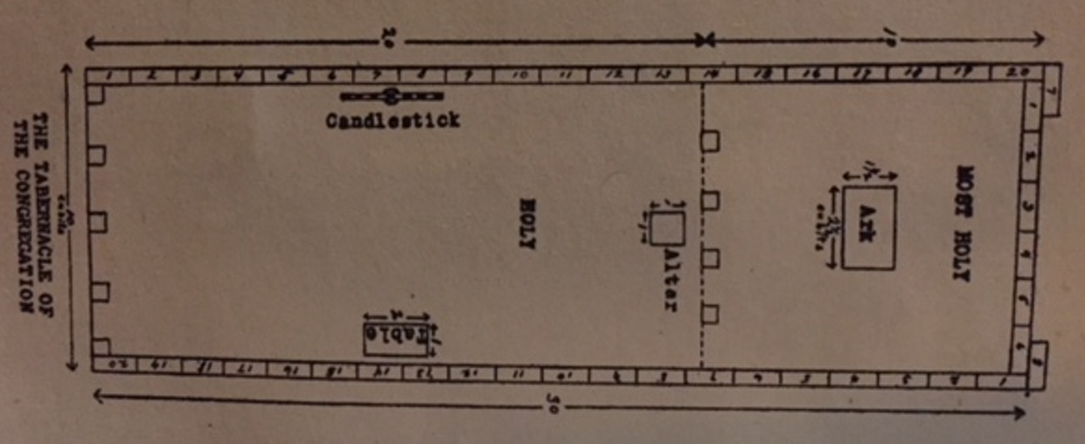

TABERNACLE SHADOWS
OF
THE BETTER SACRIFICES

CHAPTER I
THE TYPICAL TABERNACLE
The Camp--The Court--The Tabernacle--The Brazen Altar--The Laver-- The Table--The Lampstand--The Golden Altar--The Mercy Seat and Ark--The Gate--The First Veil--The Second Veil--The Significance of These and Their Antitypes.
THE Tabernacle which God commanded the people of Israel to construct in the Wilderness of Sin, and in connection with which all their religious services and ceremonies were instituted, was, the Apostle Paul assures us, a shadow of good things to come. (Heb. 8:5; 10:1; Col. 2:17) In fact, the whole nation of Israel, as well as its laws and its religious services and ceremonies, was typical. This being true, our understanding of the plan and work of salvation now in progress, as well as their future development, cannot fail to be greatly enlightened by a careful study of those "shadows" which the Israelites, for our edification, were caused to repeat year by year continually until the Gospel age introduced their antitypes--the realities. 1 Pet. 1:11; Heb. 10:1-3
It is not simply to gain a historical knowledge of the Jewish forms, ceremonies and worship that we come to the investigation
T12
of this subject, but that we may be edified by understanding the substance from an examination of the shadow--as God designed in arranging it.
We shall fail to attach sufficient weight and importance to the shadow unless we realize how carefully God guided and directed all of its details. First, he took Moses up into the mount and gave him an illustration of the manner in which things were to be made; Secondly, he charged him to be careful of every particular--"See, saith he, that thou make all things according to the pattern shewed to thee in the mount." (Heb. 8:5; Exod. 25:40) So, too, with all the minutiae of the service: every jot and tittle had to be exactly performed in the type, because it illustrated something greater and more important to come afterward. And in order that these shadows might all be exactly performed, and that the people might not become careless, the usual penalty for any violation was death. For instances see Exod. 28:43; Num. 4:15,20; 17:13; 2 Sam. 6:6,7; Lev. 10:1,2
Realizing God's care in making the "shadow" should not only give us confidence in its correctness, that not one jot or tittle of it shall fail until all be fulfilled (Matt. 5:18), but should also awaken in us so great an interest in God's plan as would lead us to examine closely and search carefully for the meaning of those shadows. And this, with God's promised blessing, we now purpose to do, assured that among those who are truly God's consecrated ones--his children begotten of his Spirit--"he that seeketh findeth; and to him that knocketh, it shall be opened."
The Tabernacle's Construction
The directions given to Moses for the construction of the Tabernacle may be found in Exod. 25 to 27, and the account of the performance of the work, in Exod. 35 to 40. Briefly stated, the Tabernacle was a house constructed of a
T13
series of boards of shittim (acacia) wood, "overlaid" or plated with gold, set on end into sockets of silver, and firmly fastened together by bars of the same wood, also covered with gold.
This structure was 15 feet wide, 15 feet high and 45 feet long, and open at the front or east end. It was covered by a large white linen cloth, interwoven with figures of cherubim, in blue, purple and scarlet. The open end, or front of the structure, was closed by a curtain of similar material to the covering cloth, called the "Door," or first veil. Another cloth of the same material, similarly woven with figures of cherubim, called the "Veil" (or second veil), was hung so that it divided the Tabernacle into two apartments. The first or larger apartment, 15 feet wide and 30 feet long, was called the "Holy."* The second or rear apartment, 15 feet wide and 15 feet long, was called the "Most Holy." These two apartments constituted the Tabernacle proper; and a tent was erected over them for shelter. It was made of a covering of cashmere cloth or goat hair, another of ram skins dyed red, and another of seal skins (mistranslated badger skins).
______________
*In the English translation this is frequently, though improperly, called the "holy place," and in such instances the word place will be found in italics, indicating that it has been supplied by the translators, as, for instance, in Exod. 26:33. This error is quite confusing, as the "Court" was properly called the "holy place." When place is not in italics, the "Court" is always meant. See Lev. 14:13 and 6:26,27. In some instances the "Holy" is termed the "Tabernacle of the congregation."
The "Most Holy," or "Sanctuary," is also sometimes called the "Holy place"--place in italics. Instances, Lev. 16:17,20,23. In referring to these apartments, we will call them, severally, the "Court," "The Holy" and "The Most Holy."
A lack of appreciation of the interest of Christians in these typical pictures and of the necessity for uniform exactness, on the part of the translators of Leviticus, must have been the cause of the varied translations which have so aided in confusing the student.
T14
The Holy Court or Holy Place
The Tabernacle was surrounded by a yard, or "Court," toward the rear of which it stood. This court, 75 feet wide and 150 feet long, was formed by a fence of linen curtains, suspended from silver hooks, set in the tops of wooden posts 7 1/2 feet high, which were set in heavy sockets of copper (mistranslated brass), and braced, like the tent which covered the Tabernacle, with cords and pins. This enclosure was all holy ground, and was therefore called the "Holy Place"--also the "Court of the Tabernacle." Its opening, like the door of the Tabernacle, was towards the east, and was called the "Gate." This "Gate" was of white linen, interwoven with blue, purple and scarlet.
It will be noticed that the three entrance passages, viz., the "Gate" into the "Court," the "Door" into the "Holy" and the "Veil" into the "Most Holy," were of the same material and colors. Outside the Tabernacle and its "Court" was the "Camp" of Israel surrounding it on all sides at a respectful distance.
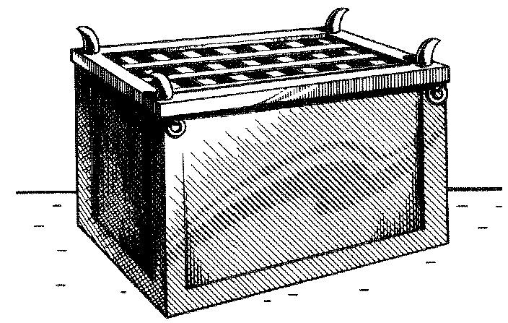
THE BRAZEN ALTAR
T15
The Furnishments
The furniture of the "Court" consisted of but two main pieces: the "Brazen Altar" and the "Laver"--with their respective implements.
Just inside the gate, and immediately in front of it, stood the "Brazen Altar." This altar was made of wood and covered with copper, and was 7 1/2 feet square and 4 1/2 feet high. Various utensils belonged to its service--fire pans (called censers), for carrying the fire to the "Incense Altar," basins to receive the blood, flesh hooks, shovels, etc.

THE LAVER
Next, between the "Brazen Altar" and the door of the Tabernacle, was the "Laver." It was made of polished copper, and was a receptacle for water; at it the priests washed before entering the Tabernacle.
The furniture of the Tabernacle consisted of a "Table," a "Candlestick" and an "Incense Altar" in the "Holy," and the "Ark of the Testimony" in the "Most Holy."
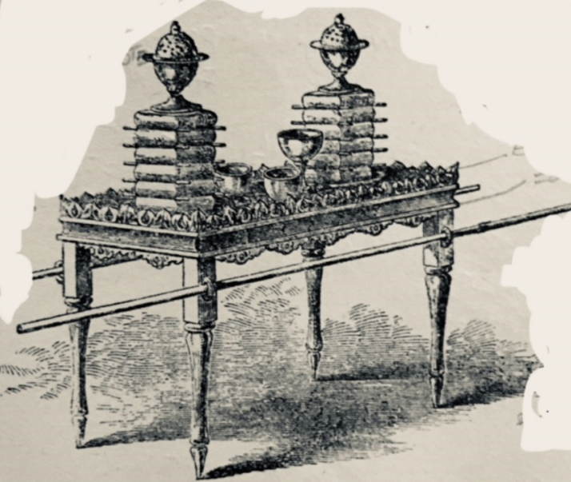

THE TABLE OF SHEW-BREAD
T16
Within the Tabernacle, in the first apartment, the "Holy," on the right (north), stood the Table of "Shewbread"-- a wooden table overlaid with gold; and upon it were placed twelve cakes of unleavened bread in two piles, with frankincense on top of each pile. (Lev. 24:6,7) This bread was proper for the priests only to eat: it was holy, and was renewed every seventh or Sabbath day.
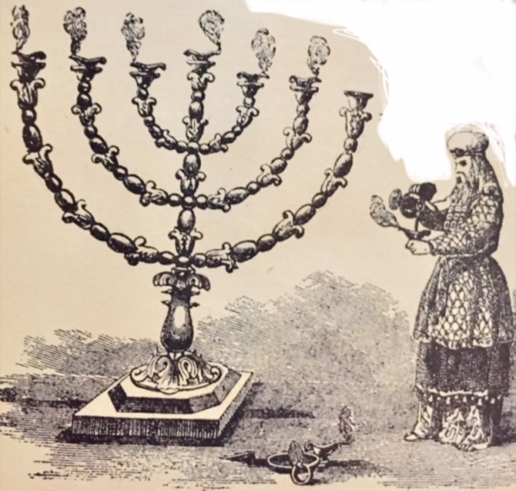
THE GOLDEN CANDLESTICK
Opposite the "Table of Shew-bread" stood the "Candlestick," made of pure gold, beaten work (hammered out), having seven branches, and in each branch a lamp. It was the only light in the "Holy"; for, as we have seen, the natural light was obscured by the walls and curtains, and there were no windows. Its seven lamps were cared for, trimmed, supplied with oil, etc., by the High Priest himself,
T17
who at such times was to offer incense at the Golden Altar.

THE GOLDEN ALTAR - THE INCENSE ALTAR

Farther on, close up to the "Veil," stood a small altar, of wood covered with gold, called the "Golden Altar" or "Incense Altar." It had no fire upon it except what the priests brought in the censers which they set in the top of this "Golden Altar," and then crumbled the incense upon it, causing it to give forth a fragrant smoke or perfume, which, filling the "Holy," penetrated also beyond the "second veil" into the Most Holy or Holy of Holies.

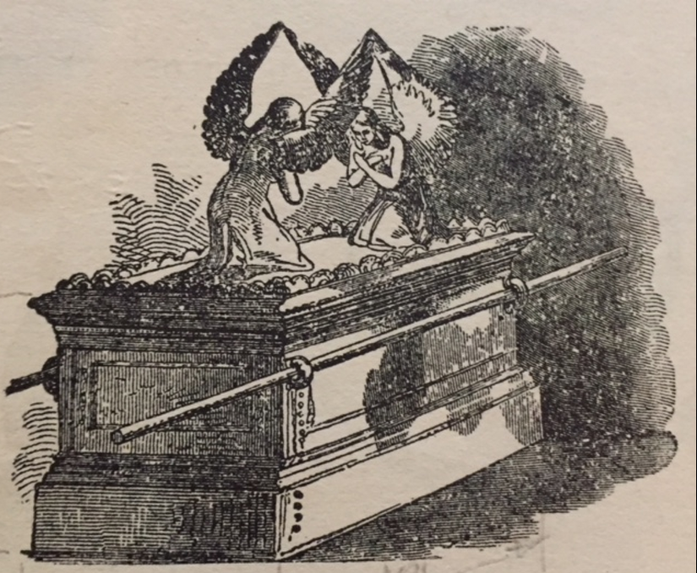

THE ARK OF THE TESTIMONY
Beyond the "Veil," in the "Most Holy," there was but one piece of furniture--the "Ark." It was a rectangular box made of wood overlaid with gold, having a lid or cover of pure gold called the Propitiatory or "Mercy Seat." Upon it (and of the same piece), were two cherubs of gold--beaten work. Within this "Ark" (under the Propitiatory) were placed the golden bowl of manna, Aaron's rod that budded, and the two tables of the Law. (Heb. 9:4) Upon the Propitiatory a supernatural light appeared, shining out between the cherubim, representing the Divine presence. This was the only light in the "Most Holy."
It is noticeable that all the furniture inside the Tabernacle
T18
was of gold, or covered with gold, while in the "Court" everything was of copper.

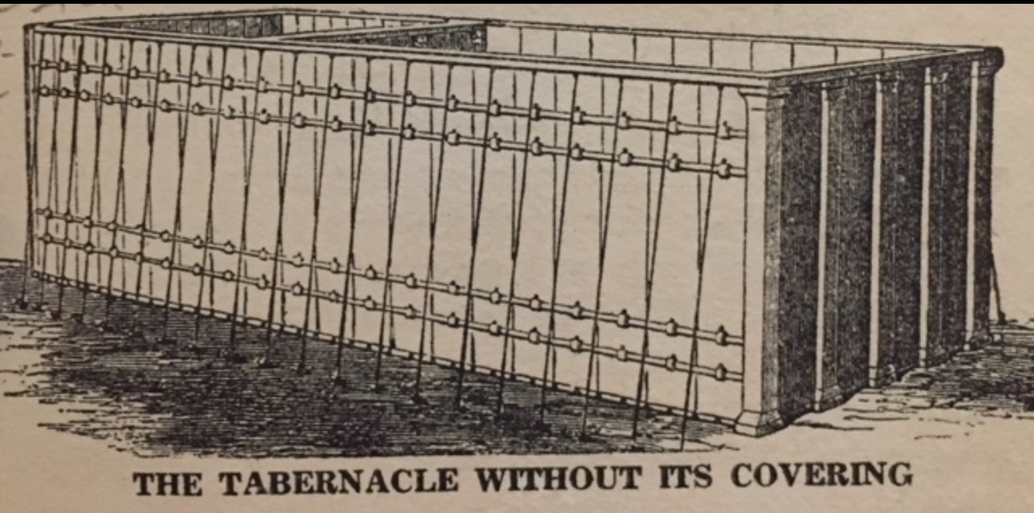
Wood, which was the base covered with these metals, was used, we believe, to make the articles of lighter weight, more easily portable, than if of solid metal. This was an important consideration when they traveled. The vessels of the Temple, representative of the same things, were of solid metals. (1 Kings 7:47-50) These two metals, gold and copper, were used, we think, to represent two different natures--copper representing the human nature in its perfection, a little lower than the angelic nature; and gold representing the divine nature, far above angels, principalities and powers. As gold and copper are much alike in their appearance, yet different in quality, so the human nature is an image and likeness of the divine, adapted to earthly conditions. It will be noticed that the arrangement of
The Camp, Court and Tabernacle

thus distinctly separated and differentiated into three general divisions, represent three distinct classes blessed by the atonement; and the two parts of the Tabernacle represent two conditions of one of these classes.
"The Camp" represented the condition of the world of mankind in sin, needing atonement and desiring it and its blessings, however indistinctly it analyzes its cravings and groanings. In the type the "Camp" was the nation of Israel at large, which was separated from all holy things by the curtain of white linen, representing to those within a wall of faith, but to those without a wall of unbelief which hindered their view of and access to the holy things within. There was only one gateway to enter the "Holy Place" or "Court"; the type thus testifying that there is but one way of access to God--one "gate"--Jesus. "I am the way,...no man cometh unto the Father but by me." "I am the door." John 14:6; 10:9
T19
"The Court," represented the condition of Justification, entered through faith in Christ, the "gate." Into this "Court" only Levites (typical of justified believers) were allowed to come, during the Atonement Day. These had access to the "Brazen Altar" and to the "Laver," and did service in the "Court," but had no right as merely Levites (believers) to go into the Tabernacle; no, nor even to look into it. (Num. 4:19,20) In the "Court" all things were of copper, to indicate that the class admitted there were justified men. The "Court" did not represent the condition of the spiritual class during the Gospel age, though the priests, in sacrificing and washing, used it also.
"The Tabernacle" building, with its two parts, represented the two conditions of all who undergo a change of nature from human to spiritual. The first apartment, the "Holy," represented the conditionof all those who (as Levites--justified believers) have consecrated their human nature to death, that they might become partakers of the divine nature (2 Pet. 1:4), having been begotten of the Spirit. Its second apartment, the "Holy of Holies," beyond the "Veil"-- death--represented the condition of the faithful "overcomers" who will attain to the divine nature. These, after having completed their consecration in death, will be fully changed, born from the dead in the First Resurrection, to the divine nature and organism. No human being, be he ever so full of faith, be he washed from every sin, and in God's sight justified freely from all things and reckoned perfect, can have any place or privilege in the spiritual things represented in the interiors of the Tabernacle and Temple. He cannot even look into spiritual things, in the sense of appreciating them. But, during the Gospel age, such are "called" to consecrate and sacrifice their human nature in God's service, and to inherit instead the spiritual nature--as members of the Body of Christ. "The natural man receiveth not the things of the Spirit...neither can he know
T20
them, because they are spiritually discerned." 1 Cor. 2:14
The fact that all things in the Tabernacle were made of gold, representative of the divine nature, implies that it represented the condition of such only as are called to the divine nature. Only those of the Levites who were consecrated to the work of sacrificing (the Priests) had access to the Tabernacle; so only those of the household of faith who are consecrated to sacrifice, even unto death, enter the divine conditions represented in the Tabernacle.
The "Court," the justified human condition, is entered by faith only; but while we must retain the faith that justifies, we must do more, if we would experience a change of nature and become "new creatures," "partakers of the heavenly calling," to be "partakers of the divine nature." Entering the "Holy," therefore, implies our full consecration to the Lord's service, our begetting of the spirit and our start in the race for the prize of the divine nature-- the terms of which are, faithfulness to our vow, crucifying the justified flesh, presenting our human wills and bodies living sacrifices to God; no longer to seek human pleasure, honor, praise, etc., but to be dead to these and alive to the heavenly impulses. Yet, into this condition, also, we still come through Christ Jesus our Lord, who not only opened for us the "Gate" of justification through faith in his blood, but who also opened the "Door" (the first veil) into the Tabernacle, "a new way of life," as spirit beings, through and beyond the second veil, by the sacrifice of our justified flesh.
Hence the two apartments of the Tabernacle, the "Holy" and the "Most Holy," represented two phases or stages of the new life to which we are begotten by the holy Spirit.
The "Holy" represented the present condition of those begotten
T21
of God through the Word of Truth. (Jas. 1:18) These, as heavenly minded "new creatures," though still "in the flesh," have their real (inner) life and walk with God within the first veil of consecration, and beyond the intellectual sight of the world and the unconsecrated believers. These enjoy the inner light of the "golden candlestick," while others are in "outer darkness"; these eat of special spiritual food, represented in the unleavened "bread of presence," and offer incense at the golden altar, acceptable through Christ Jesus.
The "Most Holy" represented the perfected condition of those new creatures who, faithful unto death, gain the great prize of our high calling through a share in the first resurrection. (Rev. 20:6) Then, beyond both veils--the fleshly mind and the fleshly body--they will possess glorious spiritual bodies as well as spiritual minds. They will be like their Leader and Forerunner beyond the veil, who, having entered as our Redeemer, hath consecrated for us this new and living way--or new way of life. Heb. 10:20; 1 John 3:2
The spiritual-minded creature in the "Holy" by faith looks forward through the rent "Veil" into the "Most Holy," catching glimpses of the glory, honor and immortality beyond the flesh; which hope is as an anchor to the soul, sure and steadfast, entering into that which is beyond the veil. Heb. 6:19; 10:20
We see, then, that justification by faith, our first step toward holiness, brings us into a condition of "peace with God through our Lord Jesus Christ." (Rom. 5:1) When our sins are forgiven, or reckonedly covered with Christ's righteousness, we are a step nearer to God, but still human--in the "Court." If we would attain the prize of the high calling which is of God in Christ Jesus, and enter through the "Holy" into the "Most Holy," we must follow
T22
in the Footsteps of Jesus, our Leader and Head--"the High Priest of our profession" [i.e., the High Priest of our order of priesthood] the "royal priesthood." Heb. 3:1; 1 Peter 2:9--
(1) By faith in Christ's ransom-sacrifice, represented in the Brazen Altar, we enter the "Gate" to the "Court"--the veil of unbelief and sin is passed. This step is one which our Lord Jesus never took, because not being of Adamic stock, but holy, harmless, separate from sinners, he never was outside the Court condition.
(2) Renouncing our justified human wills, and all our human aspirations and hopes, we pass the first veil, or veil of human-mindedness--counting the human will as dead; henceforth consulting not it, but the will of God only. We now find ourselves as "new creatures" in the "Holy"--in the first of the "Heavenlies" or Holies (Eph. 2:6--Diaglott), and begin to be enlightened by the "Golden Candlestick" (God's Word) respecting spiritual things--"the deep things of God," and to be refreshed and strengthened daily with the truth, as represented in the "shew-bread," lawful for only the Priests to eat. (Matt. 12:4) And thus enlightened and strengthened, we should daily offer up sacrifices at the "Golden Altar," acceptable to God through Jesus Christ--a sweet perfume to our Father. 1 Pet. 2:5*
Thus all the saints, all the consecrated, are in a "heavenly" or "holy" condition now--"seated [at rest and in communion] with Christ in [the first of these] heavenly places," but not yet entered into the "holiest of all." No, another veil must first be passed. As the passing of the preceding veil represented the death of the HUMAN will, so the passing of the second veil represented the death of the HUMAN body; and
________________
*The word spiritual in this text is omitted by the oldest Greek MS, the Sinaitic, with evident propriety. Not spiritual but human rights, privileges, life, etc., are sacrificed.
T23
both are requisite to complete our "sacrifice." Both fleshly mind and fleshly body must be left behind before we can enter into the "holiest of all"--perfected as partakers of the divine nature and its spirit conditions: for flesh and blood cannot inherit the Kingdom of God. (1 Cor. 15:50) Compare John 3:5,8,13.
With these thoughts before our minds, respecting the three conditions represented by these three places, "Camp," "Court" and "Tabernacle," in our next study we will note particularly the three classes which come under these conditions; viz., the Unbelieving World, Justified Believers and the Saints or Consecrated Believers, typified respectively by Israelites, Levites and the Priesthood.
T24
The Tabernacle
"What lone mysterious abode is this,
Surrounded by a wall of spotless white;
By day an altar in the wilderness,
A silent watcher on the plain by night?
"Who dwells within its consecrated veil,
To secular and alien feet denied?
Who answers when the priest, white-robed and pale,
Sprinkles the blood by 'bulls and goats' supplied?
"Think you that He of name omnipotent
Required for naught these oft-repeated rites,
Or gratified mere vanity by scent
Of incense, broidered robes and altar-lights?
"Nay, verily! The curious tapestries,
The vessels wrought of silver, copper, gold,
The ceremonious modes of sacrifice,
All 'better things' of Gospel times foretold.
"And happy he whose reverent gaze discerns
What 'types and shadows' could but dimly trace:
His offering on the golden altar burns,
He solves the mysteries of the 'holy place.'
"Upon the blood-stained mercy-seat he reads
Atonement sealed by him who went before,
And from the open heavens the Father speeds
The riches of his love and grace to outpour."

